## Password Strength Design Outline

### Constants

1. The minimum character length is set to 7
2. The maximum character length is set to 20

### User Inputs

1. An alphanumeric password

### Program Output

1. If the password is valid, the program tells the user that the password is valid
2. Correct error messages for the cases; when the password length does not match the criteria when the password does not contain at least one digit or character, and if the password has a space.

### Steps on how to achieve this

1. Prompt the user for an alphanumeric password.
2. Check if the length of the password is less than the minimum assigned length or if it greater than the maximum set length.
   1. If the check fails, the program outputs an error.
3. Loop through the password and check if the password contains at least one digit or one letter.
   1. If the check fails, the program outputs an error.
4. Check if the password contains a space.
   1. If the check fails, the program outputs an error.
5. Tell the user that the password they have entered is valid.

### 

### Test Cases

| **Test Case** | **Password** | **Output** |
| --- | --- | --- |
| Valid password | averyvalidpassword1 | Your password is valid |
| Short password | pswd | Password should have at least 7 characters and at most 20 characters |
| Password without digit | pswdwithoutdigit | Password should contain atleast one alphabetic character or one number |
| Password with spaces | pswd with spaces | Password should not contain a space |

### Screenshots

#### Test Case 1: Valid Password



#### Test Case 2: Short Password

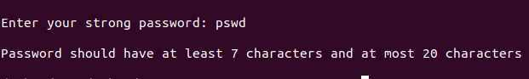

#### Test Case 3: Password without digit

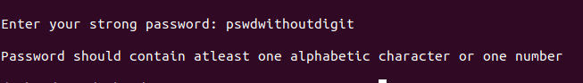

#### Test Case 4: Password with spaces

